In [ ]:
%pip install scikit-learn statsmodels seaborn scipy

In [ ]:
import pandas as pd
import numpy as np
import matplotlib.pyplot as plt
import seaborn as sns

from scipy import stats
from sklearn.model_selection import train_test_split from sklearn.linear_model import LogisticRegression from sklearn.metrics import (
accuracy_score, confusion_matrix,
classification_report, roc_auc_score
)
from sklearn.pipeline import Pipeline
from sklearn.preprocessing import StandardScaler
import statsmodels.api as sm
from statsmodels.stats.outliers_influence import variance_inflation_factor

print("Libraries imported successfully!")

In [8]:
df = pd.read_csv("train.csv")

print("Dataset loaded successfully!") print("Dataset shape:", df.shape)

df.head()

Dataset loaded successfully! Dataset shape: (891, 12)

Out[8]:
7.2

0 1 0 3

Braund, Mr. Owen
PassengerId | Survived | Pclass | Name | Sex | Age | SibSp | Parch | Ticket

Harris

male 22.0 1 0

A/5 21171

1
2
1
1
Cumings, Mrs. John Bradley (Florence
Briggs Th...
female 38.0
1
0 PC 17599 71.2

2 | 3 | 1 | Heikkinen, STON/O2.  3 Miss. female 26.0 0 0 3101282 7.9  Laina
3 | 4 | 1 | Futrelle,  Mrs.  1 Jacques female 35.0 1 0 113803 53.1 Heath

4 5 0 3
Allen, Mr. William Henry

male 35.0 0 0 373450 8.0

(Lily May
Peel)
C C
In [11]:
print("Missing values:") print(df.isnull().sum())

print("\nData types:") print(df.dtypes)

Missing values:  PassengerId | 0
Survived | 0
Pclass | 0
Name | 0
Sex | 0
Age | 177
SibSp | 0
Parch | 0
Ticket | 0
Fare | 0
Cabin | 687
Embarked  dtype: int64 | 2
Data types: PassengerId | int64
Survived | int64
Pclass | int64
Name | str
Sex | str
Age | float64
SibSp | int64
Parch | int64
Ticket | str
Fare | float64
Cabin | str
Embarked  dtype: object | str
In [13]:

Chi-square statistic: 260.717
from scipy.stats import chi2_contingency

table = pd.crosstab(df["Sex"], df["Survived"])
chi2, p_value, dof, expected = chi2_contingency(table) print("Chi-square statistic:", round(chi2, 3))
print("P-value:", p_value)

if p_value < 0.05:
print("Reject H0: Gender and survival are significantly associated.")
else:
print("Fail to reject H0: Evidence of association is insufficient.")
P-value: 1.1973570627755645e-58
Reject H0: Gender and survival are significantly associated.

In [15]:
# Select relevant columns
model_df = df[
["Survived", "Pclass", "Sex", "Age", "Fare", "SibSp", "Parch"]
].copy()

# Fill missing values
model_df["Age"] = model_df["Age"].fillna(model_df["Age"].median())

# Convert gender into numeric values
model_df["Sex"] = model_df["Sex"].map({"male": 0, "female": 1})

# Check for missing values

X = model_df[["Pclass", "Sex", "Age", "Fare", "SibSp", "Parch"]] y = model_df["Survived"]

X_train, X_test, y_train, y_test = train_test_split( X, y, test_size=0.2, random_state=42, stratify=y
)

model = Pipeline([
("scaler", StandardScaler()),
("logistic", LogisticRegression(max_iter=1000))
])

model.fit(X_train, y_train)

y_pred = model.predict(X_test)
y_prob = model.predict_proba(X_test)[:, 1]

print("Accuracy:", round(accuracy_score(y_test, y_pred), 3)) print("ROC-AUC:", round(roc_auc_score(y_test, y_prob), 3))
print("\nConfusion Matrix:")
print(confusion_matrix(y_test, y_pred)) print("\nClassification Report:")
print(classification_report(y_test, y_pred))
print("Missing values after cleaning:") print(model_df.isnull().sum())

print("\nPrepared dataset shape:", model_df.shape) model_df.head()
Missing values after cleaning: Survived 0
Pclass 0
Sex 0
Age 0
Fare 0
SibSp 0
Parch 0
dtype: int64

Prepared dataset shape: (891, 7)

Out[15]: | Survived |  | Pclass | Sex | Age | Fare | SibSp | Parch
 | 0 | 0 | 3 | 0 | 22.0 | 7.2500 | 1 | 0
 | 1 | 1 | 1 | 1 | 38.0 | 71.2833 | 1 | 0
 | 2 | 1 | 3 | 1 | 26.0 | 7.9250 | 0 | 0
 | 3 | 1 | 1 | 1 | 35.0 | 53.1000 | 1 | 0
In [16]: | 4 | 0 | 3 | 0 | 35.0 | 8.0500 | 0 | 0

Accuracy: 0.804
ROC-AUC: 0.852

Confusion Matrix:
[[95 15]
[20 49]]

Classification Report:
# Logistic regression coefficients
logistic_model = model.named_steps["logistic"]

coef_table = pd.DataFrame({ "Feature": X.columns,
"Coefficient": logistic_model.coef_[0]
})

print("Logistic Regression Coefficients:") print(coef_table.sort_values(
by="Coefficient", ascending=False
).round(4))

 |  | precision | recall | f1-score | support
 | 0 | 0.83 | 0.86 | 0.84 | 110
 | 1 | 0.77 | 0.71 | 0.74 | 69
 | accuracy |  |  | 0.80 | 179
 | macro avg | 0.80 | 0.79 | 0.79 | 179
 | weighted avg | 0.80 | 0.80 | 0.80 | 179
In | [17]:

Logistic Regression Coefficients:
cm = confusion_matrix(y_test, y_pred)

plt.figure(figsize=(6, 4)) sns.heatmap(
cm, annot=True, fmt="d", cmap="Blues",
xticklabels=["Predicted No", "Predicted Yes"], yticklabels=["Actual No", "Actual Yes"]
)
plt.title("Logistic Regression - Confusion Matrix") plt.xlabel("Prediction")
plt.ylabel("Actual") plt.tight_layout()
plt.show()

 |  |  | Feature | Coefficient
 |  | 1 | Sex | 1.2969
 |  | 3 | Fare | 0.1464
 |  | 5 | Parch | -0.0936
 |  | 4 | SibSp | -0.2868
 |  | 2 | Age | -0.5014
In | [18]: | 0 | Pclass | -0.8936

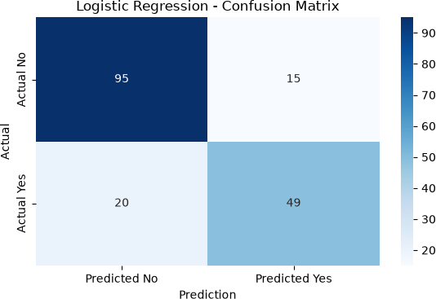

plt.figure(figsize=(7, 5)) plt.scatter(y_prob, y_test - y_prob, alpha=0.5) plt.axhline(0, linestyle="--") plt.xlabel("Predicted Probability of Survival") plt.ylabel("Actual Outcome - Predicted Probability") plt.title("Logistic Regression Residual Diagnostic") plt.tight_layout() plt.show()

In [20]:
plt.figure(figsize=(7, 5))
plt.scatter(y_prob, y_test - y_prob, alpha=0.5) plt.axhline(0, linestyle="--")
plt.xlabel("Predicted Probability of Survival")
plt.ylabel("Actual Outcome - Predicted Probability") plt.title("Logistic Regression Residual Diagnostic") plt.tight_layout()
plt.show()

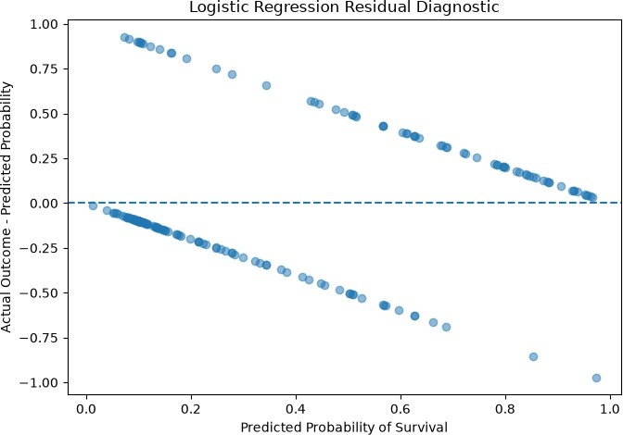

Week 3: Statistical Modeling and Hypothesis Testing

Research Question
Are passenger characteristics such as gender, age, passenger class, fare, and family size associated with survival on the Titanic?

Hypothesis Testing
A Chi-square test was conducted to examine the relationship between gender and survival.
  - Chi-square statistic: 260.717
  - P-value: 1.197 × 10⁻⁵⁸

Significance level: 0.05
Since the p-value is less than 0.05, the null hypothesis was rejected. The results indicate a statistically significant association between gender and survival.

Logistic Regression Results
A Logistic Regression model was trained using passenger class, gender, age, fare, siblings/spouses, and parents/children aboard.

  - Accuracy: 80.4%
  - ROC-AUC: 0.852

Test samples: 179
The accuracy indicates that the model correctly classified approximately 80.4% of passengers in the test set. The ROC-AUC score of 0.852 indicates good ability to distinguish between passengers who survived and those who did not.

Confusion Matrix Interpretation

Predicted Not Survived | Predicted Survived

Actually Not Survived | 95 | 15
Actually Survived | 20 | 49
The model correctly identified 95 passengers who did not survive and 49 passengers who survived. It incorrectly classified 15 non-survivors as survivors and 20 survivors as non-survivors.

Classification Report
  - Class 0 (Not Survived): Precision = 0.83, Recall = 0.86, F1-score = 0.84.
  - Class 1 (Survived): Precision = 0.77, Recall = 0.71, F1-score = 0.74.
The model performed somewhat better at identifying passengers who did not survive than at identifying passengers who survived.

Limitations
The dataset contains missing values, and the model uses only a subset of available passenger characteristics. Other relevant factors may not be included. Statistical association does not prove causation, and the results should not automatically be generalized to other populations.

Conclusion
The Chi-square test found a statistically significant association between gender and survival. Logistic Regression achieved 80.4% accuracy and a ROC-AUC of 0.852 on the held-out test set. These results suggest that the selected passenger characteristics provide useful information for predicting Titanic survival.

